# CHAPTER ONE

## 1.0 Introduction

## 1.1 Background of The Study

As the global population continues to grow and living standards improve, the demand for energy and health has been increasing steadily. However, this rising energy consumption has led to concerns about global warming and environmental pollution. It has become crucial to shift towards renewable energy sources to mitigate these issues and ensure a sustainable future.

Oxygen is used for medical purposes and hydrogen stands out as a promising energy carrier in this context. When used as a fuel, hydrogen produces only water as a byproduct, making it environmentally friendly and free from carbon emissions. This characteristic makes hydrogen an attractive alternative to traditional fossil fuels, which release greenhouse gases and contribute to climate change.

Hydrogen offers several advantages as an energy carrier, including high energy density, versatility in applications, and the potential for long-term energy storage. It can be produced from various renewable sources, such as water electrolysis using renewable electricity, biomass conversion, or even through biological processes.

By investing in the development and utilization of oxygen as a medical resource and hydrogen as a clean energy carrier, we can reduce our dependence on fossil fuels, decrease carbon emissions, and work towards a more sustainable and environmentally friendly energy future. (Kazim & Veziroglu, 2011). Hydrogen possesses several attractive properties as an energy carrier, including its high energy density. The energy density of hydrogen is approximately 140 MJ/kg, which is more than two times higher than that of typical solid fuels, such as coal or gasoline, which have an energy density of around 50 MJ/kg.

The high energy density of hydrogen means that a relatively small amount of hydrogen can store a significant amount of energy. This makes hydrogen an efficient option for energy storage and transportation. It allows for a higher energy-to-weight ratio, making it suitable for applications where weight and space are critical factors, such as in fuel cell vehicles or portable power systems.

Furthermore, hydrogen's high energy density enables it to provide a substantial amount of energy when used as a fuel. This makes it a valuable resource for power generation, industrial processes, and various other applications where a significant amount of energy is required.

It's important to note that while hydrogen has a high energy density per unit mass, its energy density per unit volume is relatively low. This means that storing and transporting hydrogen efficiently requires appropriate infrastructure and technologies, such as high-pressure tanks or advanced cryogenic storage systems.

Overall, hydrogen's high energy density is a key advantage that contributes to its potential as a clean and sustainable energy carrier, offering opportunities for decarbonizing various sectors of the economy and addressing the challenges of global energy consumption and environmental impact. (Jun & Hongmei, 2018). Presently, the entire worldwide hydrogen production is around 500 billion cubic meters (b m3) per year (Acar & Dincer, 2014), (Rand, 2011). Hydrogen is widely used in various industrial applications due to its versatility and compatibility with different processes. Some of the major industrial applications of hydrogen include:

Fertilizer Production: Hydrogen is a crucial component in the production of ammonia-based fertilizers. It is used in the Haber-Bosch process, where it reacts with nitrogen to produce ammonia, which is then used to manufacture fertilizers. Petroleum Refining: Hydrogen is used extensively in petroleum refining processes. It is employed in hydrocracking and hydrotreating operations to remove impurities and improve the quality of petroleum products, such as gasoline, diesel, and jet fuel. Petrochemical Industry: Hydrogen is an essential feedstock for the production of various petrochemicals. It is used in processes like hydrogenation, where it reacts with unsaturated hydrocarbons to produce saturated hydrocarbons or other valuable chemicals. Fuel Cells: Hydrogen serves as a fuel source in fuel cell technology. Fuel cells convert hydrogen into electricity through an electrochemical process, offering a clean and efficient power generation option for various applications, including transportation, stationary power, and portable devices. Chemical Industries: Hydrogen is used as a reactant or reducing agent in numerous chemical reactions. It is employed in processes such as hydrogenation, methanol production, and the synthesis of various chemicals, including methanol, ammonia, and hydrogen peroxide.

The industrial applications of hydrogen demonstrate its importance in supporting key sectors of the economy, enabling cleaner and more efficient processes, and contributing to the transition towards sustainable energy solutions. (Zuttel, 2014), (Rakim, 2010), (Lim, 2015). Hydrogen has been produced from various renewable and non-renewable energy resources such as fossil fuels, especially steam reforming of methane (Boyano, 2011), (Xy et al, 2019), (Lighat et al, 2011), oil/naphtha reforming (Trane et al, 2012), (Irashni et al, 2011),(Rahimpur etal, 2013), coal gasification (Huang, 2014), (Seyitoglo, 2017), biomass (Mujeebu, 2016),(Abuadal, 2012), biological sources (Elshanourby, 2013),(Sivagurunathan, 2016) and water electrolysis (WE)(Sirakusano, 2012). Each method has its own advantages, disadvantages, efficiency levels, and capital costs, which may vary depending on specific technologies and implementation. Currently 96% of the global hydrogen production from non-renewable fossil fuels, in particular is by steam reforming of methane (Boreum, 2018). The usage of fossil fuels produces lower purity of hydrogen with high concentration of harmful greenhouse gasses (Mamuoon, 2015). The unremittingly growing the global energy needs and the limited reserves of fossil fuels together with sustainability and environmental impact need new energy approaches without any carbon emissions which has now taken attention as an environmentally friendly energy strategy possibly to replace the current fossil fuel-based energy production (Forteini, 2017), this strategy can be achieved when hydrogen is produced from the renewable water as eco-friendly and high purity of hydrogen (99.999%) can be obtained from electrolysis of water.

## 1.2 Statement of The Problem

Oxygen as a gas is used in ventilation a therapy for breathing related cases while hydrogen has several advantages over conventional fuels, including its high energy density and environmental friendliness. The development of proton exchange membrane fuel cells (PEMFCs) has made it feasible to use hydrogen on a larger scale, such as in vehicles and portable electronic devices.

However, there are still challenges that need to be addressed for the widespread adoption of hydrogen as an energy carrier and oxygen for medical purposes. The major obstacle is efficient strategies for oxygen/hydrogen production:

1. Cost: One of the significant challenges in oxygen/hydrogen production is the high cost associated with various production methods. Currently, the most common industrial method for hydrogen/oxygen requires natural gas and a reforming process. This process releases carbon dioxide as a byproduct, making it less environmentally friendly. Lowering the cost of production is crucial to making it a more viable and competitive energy option.

## 1.3 Aim and Objectives

The aim of this project is to construct a hydrogen/oxygen gas production system for renewable energy applications. The objectives are as follows:

1. To construct the hydrogen gas production/storage system
2. To test the produced system for performance appraisal.

## 1.4 Scope and Limitation of the Study

The work will deal in only the production of hydrogen/oxygen gas from electrolytic process. Different electrode configurations will be tried to establish the effect.

## 1.5 Theoretical Concept

The current contribution of electrolysis to global hydrogen/oxygen production is relatively small, around 4%. One of the main challenges is the economic viability of large-scale electrolysis. Electrolysis systems require significant investment and have higher capital costs compared to conventional hydrogen production methods, such as steam reforming of fossil fuels.

To increase the adoption of electrolysis for oxygen/hydrogen production, ongoing research and development efforts are focused on improving the efficiency and reducing the cost of electrolysis technologies. This includes advancements in electrolyzer designs, development of more efficient catalysts, and optimization of operating conditions.

Additionally, the integration of electrolysis systems with renewable energy sources is crucial to enhance the sustainability of oxygen/hydrogen production. By utilizing excess renewable energy during periods of high generation, electrolysis systems can help store and utilize that energy in the form of hydrogen, enabling a more balanced and reliable renewable energy system.

As technology advancements continue and economies of scale are achieved, it is expected that the economic barriers associated with electrolysis of water for oxygen/hydrogen production will be overcome, leading to an increased share of oxygen/hydrogen production from this renewable method. (Ciprini, 2014), (Duun, 2012). It is anticipated that this value will experience growth in the near future, despite the increasing utilization of renewable energy sources such as solar, wind, and nuclear power. At the same time, the European Energy Directive has set a target to achieve a utilization of 14% of the energy requirements from renewable sources by 2020. (Fredrickken & Niementts, 2017). Moreover, water electrolysis offers significant advantages, including high cell efficiency and a greater rate of oxygen/hydrogen production with high purity. These benefits make it even more advantageous for subsequent conversion into electrical energy using low-temperature fuel cells. (Barbir, 2015). During the electrolysis process, water molecules act as the reactant and are dissociated into hydrogen (H2) and oxygen (O2) under the influence of electricity. Water electrolysis can be categorized into four types based on their electrolyte, operating conditions, and ionic agents (OH−, H+, O2−), although the underlying operating principles remain the same. The four methods of electrolysis are as follows:

(i) Alkaline water electrolysis (AWE): (Zeng, 2010), (Shiva, 2018), (Shiva et al, 2017), (ii) Solid oxide electrolysis (SOE) (Ni et al, 2015), (Laguna, 20120 (iii) Microbial electrolysis cells (MEC) (Kadier et al, 2016). (iv) PEM water electrolysis (Fredrickken & Niementts, 2017), (Arico, 2013).

The basic reaction is described in Eq. (1).

 (1)

# CHAPTER TWO

## 2.0 Literature Review

The proposed oxygen/hydrogen production system consists of several subsystems interconnected to perform a single purpose. The sub-systems are power supply, water electrolyzer cell and storage. This chapter gives an overview of the project by providing background information on hydrogen generation and storage work by other authors on same or similar topic. Numerous works and researches have been done in the area of hydrogen gas generation systems. The following are some reviewed past principles and work carried out by different people on same or similar work.

## 2.1 Review of Related work

Water electrolysis method is by far the simplest method of producing hydrogen, involving passing electricity into an electrolyte like water. Dincer and Zamfirescu (2011) studied water electrolysis method and stated that it can be further divided into three different types based on the electrolyte used: alkaline electrolyzers, proton exchange membrane (PEM) electrolyzers, and solid oxide electrolyzers.. Commercial low temperature electrolysers were developed with efficiencies of (56% - 73%) at conditions of (70.1 - 53.4 kWh∙kg−1 H2 at 1 atm and 25˚C) by Norbeck et al (1996). Johnattan et al (2010) and Kewei et al (2022) studied the proton exchange membrane (PEM) electrolysis and solid oxide electrolysis (SOE) units’ Alkaline electrolysis systems are the most commonly compared to other water electrolysis methods. Solid oxide electrolysis (SOE) is the most electrically efficient but still under development. Corrosion, seals, thermal cycling, and chrome migration are the major challenges faced by the SOE technology. Proton exchange membrane (PEM) electrolysis systems are known to be more efficient compared to alkaline electrolyzers. They also do not face issues related to corrosion and seals, which are present in solid oxide electrolyzers (SOE). However, one drawback of PEM electrolysis systems is their relatively high cost compared to alkaline electrolyzer systems.

Alkaline electrolyzer systems, on the other hand, have the lowest capital cost among the three types and are more cost-effective. However, they have lower efficiency, leading to higher electrical energy costs in the long run. Ragnhild et al (2022) developed high pressure electrolysers units for producing pure hydrogen. The utilization of a high-pressure operation unit offers the advantage of eliminating the need for expensive hydrogen compressors. This reduces the overall cost of hydrogen production using water electrolysis systems. It is worth noting that hydrogen production through water electrolysis is generally considered to be a relatively costly method for generating hydrogen. Furthermore, current water electrolysis systems often rely on non-renewable power generation sources to produce the electricity required for the electrolysis process which limit its sustainability and environmental.

A systematic study on the electrolytic production of hydrogen gas utilizing graphite as an electrode was conducted by A.L. Yuvaraj and D. Santhanaraj in 2014. In their experiment, they connected two cylindrical rods made of Stainless Steel 316L with uniform dimensions of 20 mm in diameter and 80 mm in length. The electrodes were spaced 2 mm apart and connected to a bridge rectifier to convert AC to DC for generator operations.

Furthermore, Nikhil Narayan conducted a study in 2014 on the performance and emission characteristics of oxyhydrogen gas in a three-cylinder four-stroke petrol engine. The HHO gas electrodes were made of SS 316L wire with a thickness of 15 gauge, spiraled and glued around an acrylic core. The HHO generator was equipped with an air bubbler adjuster, electric terminals for electricity supply, and outlet valves. The study also employed high-density polyethylene as an external plate cover due to its high strength-to-density ratio and non-corrosive nature.

Similarly, Nikhil Joshi and Deepak Naik investigated onboard production of hydrogen gas for power generation in 2015. Their HHO generator was constructed using 1 mm thick SS 316L plates, cut into dimensions of 6" by 2.5". The plates were tightened together with screws and capped with PVC, with the PVC caps serving as electrode terminals and passages for HHO gas outflow.

Ahmad H. Sakhrieh et al., in 2017, conducted a study on the optimization of oxyhydrogen gas flow rate as a supplementary fuel in compression ignition combustion engines. Their HHO generator was built using 316L Stainless Steel plates, consisting of 43 plates separated by 16 silicon gaskets. The outer ends of the arranged electrodes were covered with CPVC transparent plates. The generator was designed to achieve a voltage of 2.3 V between two successive plates by placing 5 neutral plates between every negative and positive plate. The setup included a reservoir tank that supplied electrolyte solution to the generator and a bubbler that condensed water vapor accompanying the HHO gas.

The comparative analysis of performance characteristics of CI Engine with and without HHO Gas (Brown Gas) was evaluated by Ghulam Abbas Gohar and Hassan Raza in 2017. For their study, the HHO generator was developed using 29 Stainless Steel (SS0) plates. The plates were separated with a Jain sheet, and the entire reactor was fitted with SS bolts and nuts.

To overcome the corrosion problem of the alkaline electrolysers method, Ursua et al (2012) The solid polymer membrane used in PEM fuel cell technology has also been investigated for water electrolysis. However, for the water electrolysis process, high-purity deionized water is required. At the anode, the oxidation reaction occurs, resulting in the generation of oxygen, electrons, and protons. The electrons and protons then move to the cathode side through the PEM. After the protons are reduced, hydrogen gas is generated at the cathode. Bhandari et al (2014) investigated the the PEM electrolyzer system and has found to be suitable for use with fluctuating power supply sources due to its ability to facilitate fast proton transportation through the PEM membrane. However, one major challenge associated with PEM systems is their high manufacturing cost.

The solid oxide electrolyser (SOE) operates at a significantly higher temperature compared to the PEM electrolyser, with temperatures reaching up to 1000˚C. These systems typically use thermal energy instead of a part of the electrical energy Solid oxide electrolysis cell (SOEC) systems are designed to operate at high temperatures, often utilizing heat from nuclear reactors. This high-temperature operation allows SOEC systems to achieve efficiencies of up to 60%. By leveraging the thermal energy from nuclear reactors, SOEC systems can optimize the conversion of electrical energy into hydrogen through the electrolysis process. (Polat, 2018).

The gasification process is characterized as a series of thermochemical transformations occurring at elevated temperatures. It involves the interaction between an organic material such as coal and a gasifying agent, which can be oxygen, steam, air, or carbon dioxide. (Muhammad, 2011 (Orhan et al, 2010). In the autothermic gasification process, the heat required for the gasification process is generated by utilizing the carbonaceous material itself. This self-sustaining heat generation within the system distinguishes it as autothermic gasification. (Orhan et al, 2010). The water gas shift (WGS) process is employed to separate hydrogen and convert carbon monoxide into carbon dioxide. This process involves the reaction of carbon monoxide with steam, facilitated by a catalyst, to produce carbon dioxide and additional hydrogen gas. The WGS process plays a crucial role in various applications, such as hydrogen production and the purification of syngas. Researchers have explored alternative approaches for hydrogen production to address the challenges associated with coal composition and syngas hydrogen separation. Among these methods, the Bryton cycle and a thermochemical copper-chlorine cycle have emerged as promising techniques for hydrogen generation through water decomposition. These innovative processes aim to overcome the limitations associated with conventional coal-based hydrogen production and the extraction of hydrogen from syngas. (Al-Zareer and Rosen, 2018). The Koppers-Totzek coal gasification process has been extensively studied for its capability to produce high-purity hydrogen, reaching levels of up to 97%. This method has been investigated as a viable solution for hydrogen production in the near and medium term, as it allows for the practical utilization of hydrogen derived from fossil fuels. Furthermore, this process can be combined with solar thermal processes and carbon sequestration applications, enhancing its potential as a sustainable and environmentally friendly approach to hydrogen generation from fossil fuel sources. (Lynum, 1994) (Yan and Hoekman,2014).

The Pyrolysis process “can be defined as the decomposition of organic sub-stances by heat” (Jucks, and Sandhoff, 1980). The decomposition reactions mentioned have been conducted within a temperature range of 350˚C to 400˚C, with the specific temperature chosen based on the properties of the coal being used. By adjusting the temperature within this range, researchers can optimize the decomposition process to ensure efficient and effective conversion of coal into desired products. The temperature selection takes into account factors such as coal composition, reactivity, and desired reaction rates to achieve the desired outcomes. (Collot, 2002). Thermal decomposition of various hydrocarbons typically takes place at elevated temperatures, such as methane which decomposes at temperatures of 1400˚C or above. However, it has been discovered that the pyrolysis process can be effectively carried out at lower temperatures by incorporating transition metal catalysts, such as nickel (Ni), iron (Fe), or cobalt (Co). Extensive research has shown that this catalytic approach can be utilized for the pyrolysis of organic materials. (Wu and Yoshikawa, 2002) (Demirbas and Arin, 2004) (Demirbas, 2005) (Muradov, 2003), Furthermore, this catalytic pyrolysis process not only enables the decomposition of hydrocarbons but also holds promise for the production of various valuable materials such as hydrocarbons themselves, carbon nanotubes, and carbon spheres. By employing transition metal catalysts, it becomes possible to control the reaction conditions and tailor the composition and structure of the resulting products, opening up avenues for the synthesis of diverse materials with desired properties (Demirbas and Demirbas, 2003Moreover, the pyrolysis process demonstrates remarkable flexibility as it can utilize a wide range of organic fuels, thereby offering versatility in terms of feedstock selection. Additionally, this process is known for its compactness, making it suitable for various applications and installations. Furthermore, an advantage of the pyrolysis process is that it produces carbon-free by-products, minimizing environmental impact and reducing the need for further waste treatment. (Wu and Yoshikawa, 2002) (Demirbas and Arin, 2004) (Demirbas, 2005) (Muradov, 2003). While the pyrolysis process boasts several advantages, it is important to acknowledge the potential issue of fouling caused by the formation of carbon during the process. However, this challenge can be effectively mitigated through the utilization of appropriate reactor designs. By incorporating features that enhance heat transfer and promote efficient carbon removal mechanisms, such as improved reactor geometry, optimized flow patterns, and effective cleaning mechanisms, the problem of fouling can be significantly reduced. Thus, with careful reactor design considerations, the pyrolysis process can overcome the fouling challenge and maintain its operational efficiency. (Guo et al, 2005).

In summary the works reviewed above have revealed the following. Current methods of producing hydrogen/oxygen are expensive, complicated, dangerous and not ecofriendly, secondly there has been little work done on storage leaving room for further research. The implications of these revelations have led to the subject of this research, which is to develop a low cost, ecofriendly, safe and simple method for hydrogen production and storage. By implication then:

The high cost means that imported technologies by third world nations cannot be sustained especially as global economy is suffering a meltdown.

The complication in the technique means that our adopting the methods would also means our employing foreigners to supervise or handle the production.

An ecofriendly means must be devised to reduce carbon emission that would lead to a healthier planet. Further work is needed in the safe and reliable storage of hydrogen that is produced from renewable means.

## 2.2 Water electrolysis technologies

The electrolysis of water stands as one of the most promising methods for hydrogen production, primarily due to its utilization of renewable water and the generation of pure oxygen as a by-product. Moreover, the electrolysis process can leverage DC power derived from sustainable energy sources such as solar, wind, and biomass. However, the current limitation lies in the fact that only around 4% of hydrogen production comes from water electrolysis, largely due to economic considerations.

The cost-effectiveness of water electrolysis remains a significant hurdle to overcome. Factors such as the capital investment required for electrolysis equipment, energy consumption, and the availability of affordable catalyst materials impact the overall economics of the process. Extensive research and development efforts are underway to enhance the efficiency and reduce the costs associated with water electrolysis, aiming to make it a more economically viable option for large-scale hydrogen production.

By addressing these economic challenges and advancing the technology, it is expected that the percentage of hydrogen obtained through water electrolysis will increase, enabling the utilization of this clean and renewable method as a significant contributor to the hydrogen economy. (Cipriani, 2014). Despite the increasing adoption of renewable energy sources like solar, wind, and nuclear power, there is an expectation for a future increase in this value. It is noteworthy that the European Energy Directive has established a goal of attaining 14% of the overall energy demand from renewable sources by 2020. (Forteini, 2014). Moreover, water electrolysis offers several significant advantages, including high cell efficiency and a greater rate of hydrogen production with high purity. These factors contribute to its potential for further conversion into electrical energy, particularly through the utilization of low-temperature fuel cells. (Barbir, 2016). During the electrolysis process, water molecules serve as the reactant and are dissociated into hydrogen (H2) and oxygen (O2) through the application of electricity. Water electrolysis can be categorized into four types based on their electrolyte, operating conditions, and ionic agents (OH^-, H+, O2-). However, the operating principles remain the same for all cases. The four methods of electrolysis are as follows:

(i) Alkaline Water Electrolysis (AWE): (Zeng, 2010), (Shiva, 2018), (ii) Solid oxide electrolysis (SOE) (Mi et al, 2010), Laguuna, 2012) (iii) Microbial electrolysis cells (MEC) (Kadier, 2016). (iv) PEM water electrolysis (Forteini, 2014).

# CHAPTER THREE

## 3.0 Materials and Methods

This chapter presents the block diagram of the conceived system, the analysis of the circuit leading to the component value determination and selection and construction details.

## 3.1 Materials

The following materials will be required in the implementation of the project

Table 3.1. Materials

|  |  |
| --- | --- |
| **S/N** | **Materials** |
| 1 | Plastic tubing |
| 2 | 3L plastic container |
| 3 | 2LPlastic gallon |
| 4  5  6  7  8  9  10 | Transformer  Diodes  Capacitor  7812 Voltage Regulator  Foil Paper  Fixed Resistors  Switch |

## 3.3 Block Diagram

This system consists of four main stages; the power source, the regulator, the electrolyser, pre-storage, the compressor and the storage, as shown in the block diagram representation in figure 3.1.

O2

H2

H2

Power Source

Electrolyser

Storage Tank

(H2)

Storage Tank

(O2)

` Figure 3.1: Block diagram of the process

The power source is responsible for supply of current to both the. The electrolyser the heart of the work that converts the electrolyte to hydrogen and oxygen gas, it takes in electric current and send out pure hydrogen/oxygen for storage.

**3.3.1 Power Supply**

A complete power supply circuit is mainly composed of the following four main sub-blocks.

* The Transformer
* The Rectifier Circuit
* The Filter
* The Regulator

[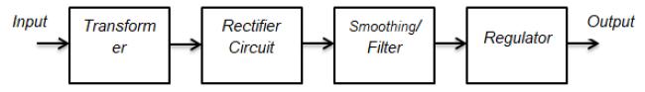](https://i1.wp.com/yamanelectronics.com/wp-content/uploads/2018/05/block-diagrame-of-5V-Dc-power-supply.png?ssl=1)

*Figure 1: Block diagram of a regulated DC power supply*

**3.3.1.1 The selection of regulator IC**

The selection of a regulator IC depends on your output voltage. In our case, we are designing for the 5V output voltage, we will select the LM7805 linear regulator IC. (Lines, 1991)

**3.3.1.2 The selection of a transformer**

There is a diode rectifier between the regulator and secondary side of the transformer with its own voltage drop across it of 1.4V so we need to compensate for this value. (Lines, 1991)

So mathematically: Vs = 7v + 1.4V (Theraja, 2002)

= 7.4V (peak value)

This means we should select the transformer with a secondary voltage value equal to or greater than 7.4v or at least 10% more than 17.4V.

From these points, for the 5V DC power supply design, we can select a transformer of current rating 1A and a secondary voltage of 9V.

**3.3.1.3 The selection of diodes for the bridge rectifier**

To select [a diode](https://yamanelectronics.com/diode/) for the bridge circuit the output load current and maximum peak secondary voltage of the transformer are considered.

Since peak reverse voltage (PIV) must be more than peak secondary transformer voltage

We select the IN4001 diode because it has a current rating of 1A more than our desire rating, and a peak reverse voltage of 50V (Theraja, 2002)

**3.3.1.4 The Selection of smoothing capacitor and calculations**

To find the proper value of capacitor, the relation is used (Theraja, 2002)

C = Io/(2πΩfoVo) (1)

*Where Io = Load current i.e., 500mA (for this project),*Vo = Output voltage i.e., 5V,  *f = Frequency= 50Hz*

C = 500mA/ (2 π * 50 *5) = 31847 * 10-6f,

Standard value = 33000uf

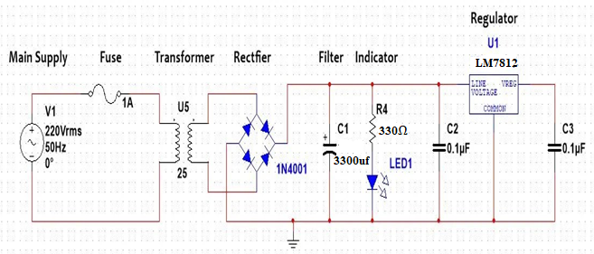

Figure 3.2: The power supply

**3.3.3 The Electrolyser**

This study focuses on the utilization of Proton Exchange Membrane (PEM) water electrolysis as a means to produce hydrogen gas. PEM water electrolysis systems, which employ a Proton Exchange Membrane or Polymer Electrolytic Membrane (PEM), offer numerous advantages over conventional alkaline technology. These advantages include enhanced energy efficiency, increased production rates, and a more compact design (Bard and Faulkner, 2001). Typically, a polymer such as Nafion is employed as the membrane material.

The PEM water electrolysis cell primarily comprises a PEM that bonds the anode and cathode together. These electrodes are typically composed of a composite material consisting of electrocatalytic particles and an electrolyte polymer.

The advantages of the PEM include:

(a). The thinness of the electrolyte membrane or diaphragm enables excellent conductivity while effectively preventing gas crossover.

(b). The electrolyte is securely immobilized within the cell, ensuring it cannot be leached out.

The disadvantages of the PEM cell include:

(a). The electrolyte incurs higher costs compared to conventional alkaline solutions

(b). Due to its corrosive nature, the electrolyte in PEMs demands the use of more expensive components within the cell. Consequently, PEMs are typically operated at slightly higher current densities compared to cells utilizing liquid alkaline electrolytes.

Typically, various electro catalysts, such as Platinum, are employed in the process. When the electrode layers are joined to the membrane, it forms what is known as the membrane electrode assembly (MEA). Porous backings like metallic meshes or sinters are used to provide electrical contact and mechanical support. Equations (1), (2), and (3) represent the reactions occurring within the electrolytic cell.

Cathode ∶ 2H++2e- → H2(g) (1)

Anode ∶ H20(I) → O2(g) + 2H+ + 2e- (2)

Therefore, the total reaction is thus:

H2(I) → H2(g) + O2(g) (3)

The mass of hydrogen produced at the cathode is proportional to the amount of current passed through the electrolysis according to the second Faraday law:

mH2 (Sanae et al, 2016) (4)

With:

mH 2= mass of hydrogen formed to the electrode (in kg)

M = molar mass of hydrogen (in kg. mole-1) (molar mass of hydrogen (H2) is approximately 2.016 grams per mole (g/mol).

Is = current through the electrolysis (in A)

t = time of electrolysis (sec)

n = number of electrons per mole of product formed (6.022 × 10^23 electrons)

F = Faraday's number (F = 96 485 C/mol)

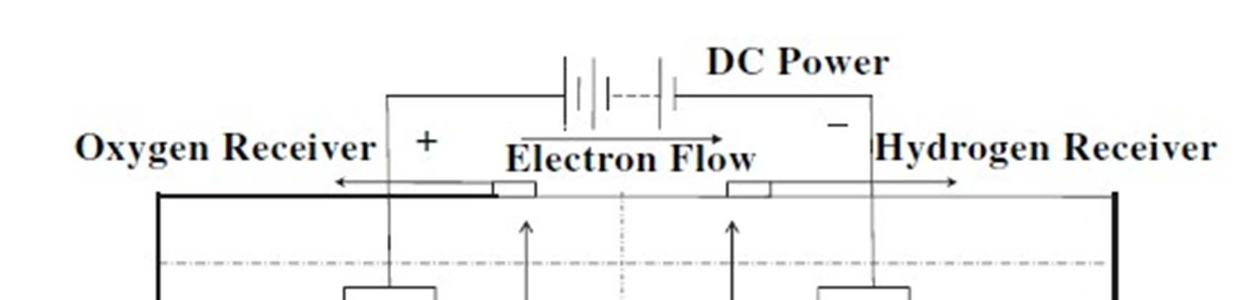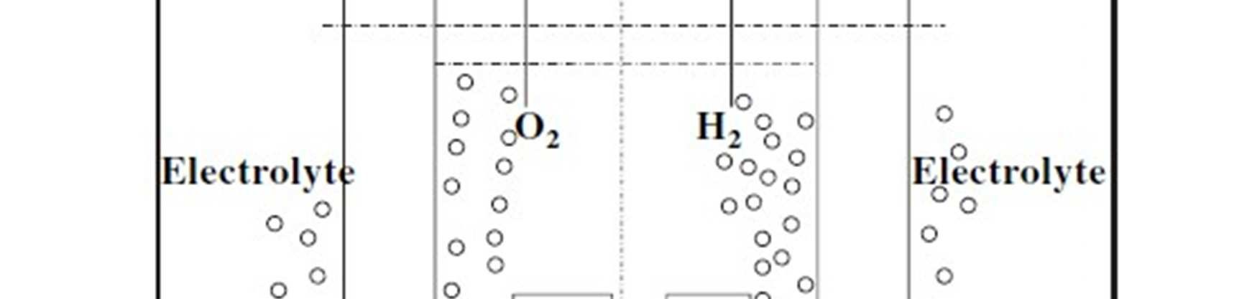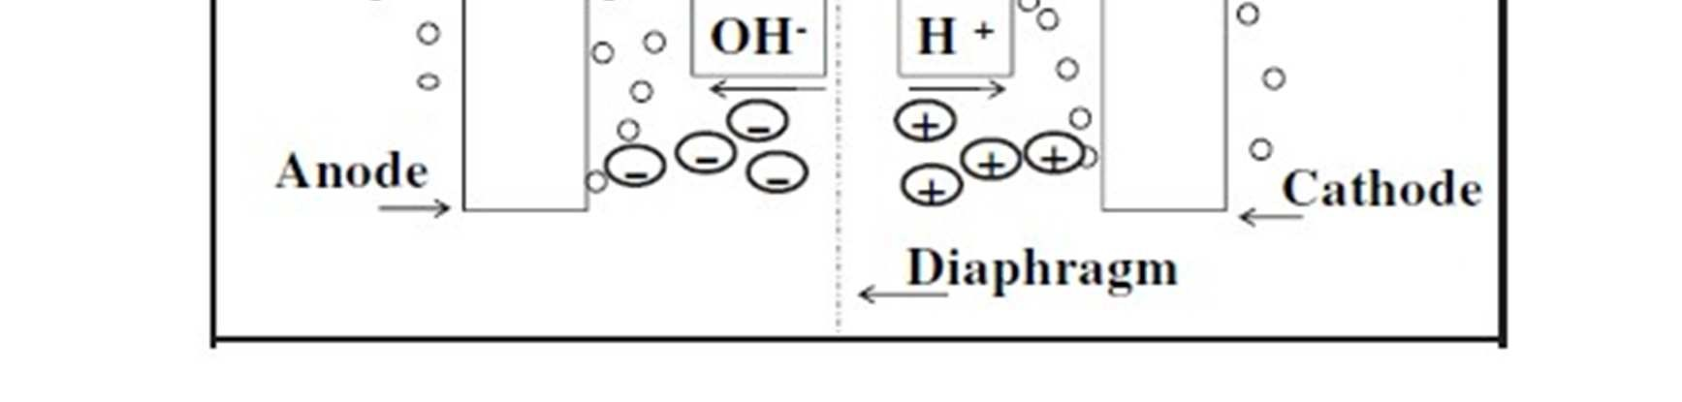

Figure 3.4: The Electrolyser design (Sanae et al, 2016)

The passage of electricity in the electrolyser will lead to a temperature rise, which can be determined thus:

Determine the electrical power being consumed by the electrolysis process. Calculate it using the formula: Power (P) = Voltage (V) * Current (I). In this case, P = 5V * 2.9A

Assume a cell efficiency of 70% as a rough approximation

Take specific heat capacity of water is approximately 4.18 joules per gram per degree Celsius (J/g°C).

The temperature rise (ΔT) $=\frac{Heat Power (joules)}{Mas of water x specific heat capacity)}$

Substituting the values, we get:

Heat Power = 5V * 2.9A * 0.7 = 10.15 watts (joules per second)

Mass of water = 2000grams (mass of 2L of water)

Specific heat capacity of water = 4.18 J/g°C

Temperature rise (ΔT) = $=\frac{10.15 (j/s)}{2000g x 4.18J/g°C)}$

10.15 J/s / (1g * 4.18 J/g°C) ≈ 0.0012°C

**3.3.4 Storage**

The storage is supposed to store hydrogen/oxygen. The storage is made of two containers one inverted and dipped into water such that when produced gas gets in water is displaced.

Since the volume of a cylinder is given by V = πr2h,

where h is the height

The volume of gas expected to be produced at the end of a session will be equal to the volume of the cylinder, therefore:

V = π *(0.09)2*(0.3) = 7.63407×10-3m3

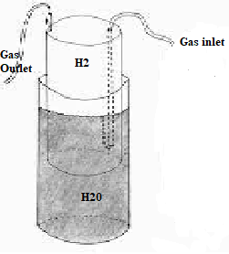

Figure 3.5: Storage design

**3.5 Method of Construction**

The solar panel and its batteries were connected as shown in the diagram below. The output of the panel feeds the battery and the battery feeds the electrolyser as well as the compressor via the limit switches.

The construction first started by assembly of galvanized steel plates in a stack manner to form the negative electrode of the electrolyser, stacking is done in order to increase the total area of contact between the electrode and water thereby further increasing the rate of the electrochemical reaction. Conductor wire was then attached to the electrode for connection to the battery.

The controlling switch was connected in series with the positive line of the compressor motor, the negative was connected directly to the negative of the battery and panel.

The materials for the electrolyser were cut to give an overall dimension of 15cm x 15cm x 10cm as specified in the figure 3.10. The nafeon was cut to the same size as the dimensions of the container. The pieces were assembled by gluing them in place with adhesive materials (4-minute glue or araldite), when formed the electrodes were inserted and held in place by plastic holders which were also held in place to the main frame by adhesive.

15cm

15cm

15cm

Figure 3.10: Dimensions of the electrolyser

The pieces of the pre storage were also cut as shown in dimensions given in figure 3.11. The top part inverted and inserted into the bottom part, with the limit switches glued at the topmost and lowest points to coincide with when the top part is filled with gas and when it is empty.

8cm

10cm

12cm

10cm

Figure 3.11: Dimensions of the storage

**3.6 Testing**

The set up was conneceted to electric supply and observations were made to ascertin production of the gas and the amount or rate of production of the gas. The volatge produced was noted s well as the temperature of the water and enviroment.

After ascertaining that the gas was being produced , During the characteristic test for hydrogen/oxygen gas, an experiment was conducted by bringing a burning candle close to the hydrogen source. As a result, the hydrogen gas ignited and produced a distinctive high-pitched sound known as a "squeaky pop." This distinct sound is indicative of hydrogen combustion and is often referred to as a small explosion. Thus, the "pop" sound serves as a recognizable characteristic when hydrogen gas is ignited. This setup is shown in figure 3.12.

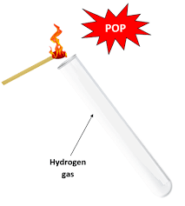

Figure 3.12: hydrogen gas test

After comfirming that hydrogen was produced, the rate of production of the the gas at the given PV produced voltage and measured temperatures of the enviroment and the water was established by To collect the gas, an inverted container filled with water is used. As the gas enters the container, it displaces the water, causing it to be pushed out. The volume of liquid that is displaced from the container serves as a measure of the volume of gas collected. By measuring the amount of water forced out, one can determine the corresponding volume of the collected gas.. This set up is shown in figure 3.13.

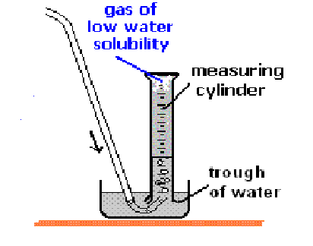

Figure 3.13: Determination of rate of gas produced

When calculating the amount of gas generated in a reaction using the method of collecting gas in an inverted container filled with water, it is important to consider that the gas collected is not pure. Instead, it comprises a mixture of the desired product gas and water vapor.

All liquids, including water, contain a certain amount of vapor in equilibrium with the liquid. This occurs because molecules from the liquid continuously escape from the liquid's surface, while other molecules from the vapor phase collide with the surface and return to the liquid. As a result, the vapor exerts a pressure above the liquid, known as the liquid's vapor pressure.

In the case of collecting gas in an inverted container filled with water, the collected gas is a mixture of hydrogen gas (H2) and water vapor. According to Dalton's law of partial pressures, the total pressure inside the container is the sum of the pressures exerted by the two components, hydrogen gas and water vapor. Therefore, when determining the total pressure or calculating the amount of gas formed, it is necessary to consider the partial pressure of each component in the mixture:

Ptot = Pgas + PH2O = Pbar.

The total pressure inside the container is a combination of the pressure exerted by the hydrogen gas and the pressure exerted by the water vapor. By subtracting the vapor pressure of water from the total pressure, you can obtain the partial pressure of the hydrogen gas, which represents the pressure exerted solely by the gas of interest.

Once you have determined the partial pressure of the hydrogen gas, you can then use it, along with other relevant factors such as temperature and volume, to calculate the amount of gas formed using appropriate gas laws, such as the ideal gas law., however in this work, the presence of the water vapor component will be neglected.